1 . man - It gives the all of its attribute and all information.
ex: man ls
2 . pwd - Print working directory, It gives current working dir.
ex: pwd
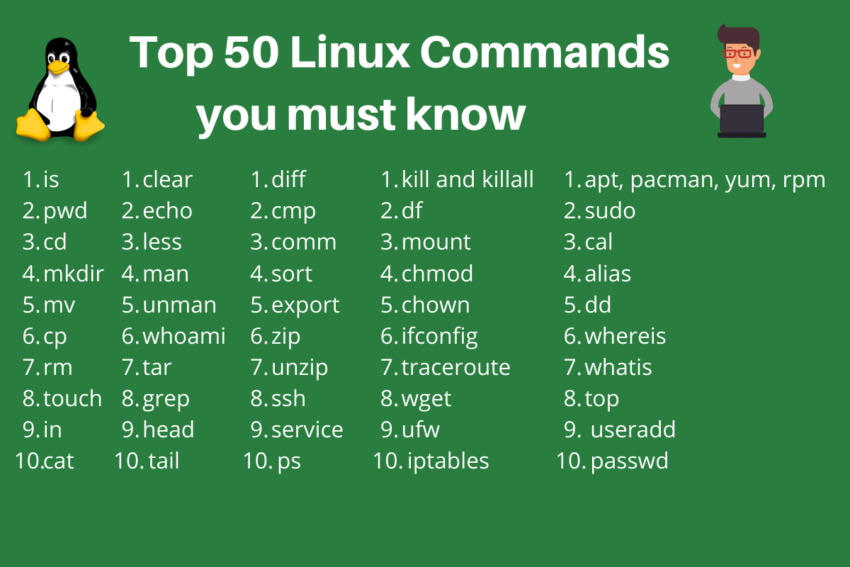
3 . cd - can change the directory
ex: cd path , cd ..
4 . ls - list all the directory in folder.
ex: ls, ls -l subFolder
5 . touch - can create a file using this.
ex: touch file.exe
6 . cat - can read and write the content into the file
ex: cat file.ext, cat > file.ext
7 . mkdir - used to create a new directory.
ex: mkdir folderName
8 . cp - used to copy the file from source to destination
ex: cd text.ext home/
9 . mv - can rename a file/directory, easily move a file/directory from one location to another.
ex: mv file.txt folder/ , mv oldName newName.
10. rm - delete the file or dir
ex: rm file1.txt, rm -r file1.txt file2.txt, rm -r *.txt
11. vi or vim - user to edit any text content inside the Vim text editor from the terminal.
ex: vi file1.txt(read content),
12. grep - it help to find text from a file like sql like '%a'
ex: grep hello file.txt, ls -lrt | grep file
13. head - head (Options) (File name), prints the first N lines of a given file content.
ex: head -n 2 file1.txt – Prints first 2 lines of the file.
14 . tail - print last n lines.
ex: tail -n 2 file1.txt – Prints Last 2 lines of the file.
15. history - view a history of all the commands previously executed
ex: history

- ls - The most frequently used command in Linux to list directories
- pwd - Print working directory command in Linux
- cd - Linux command to navigate through directories
- mkdir - Command used to create directories in Linux
- mv - Move or rename files in Linux
- cp - Similar usage as mv but for copying files in Linux
- rm - Delete files or directories
- touch - Create blank/empty files
- ln - Create symbolic links (shortcuts) to other files
- cat - Display file contents on the terminal
- clear - Clear the terminal display
- echo - Print any text that follows the command
- less - Linux command to display paged outputs in the terminal
- man - Access manual pages for all Linux commands
- uname - Linux command to get basic information about the OS
- whoami - Get the active username
- tar - Command to extract and compress files in Linux
- grep - Search for a string within an output
- head - Return the specified number of lines from the top
- tail - Return the specified number of lines from the bottom
- diff - Find the difference between two files
- cmp - Allows you to check if two files are identical
- comm - Combines the functionality of diff and cmp
- sort - Linux command to sort the content of a file while outputting
- export - Export environment variables in Linux
- zip - Zip files in Linux
- unzip - Unzip files in Linux
- ssh - Secure Shell command in Linux
- service - Linux command to start and stop services
- ps - Display active processes
- kill and killall - Kill active processes by process ID or name
- df - Display disk filesystem information
- mount - Mount file systems in Linux
- chmod - Command to change file permissions
- chown - Command for granting ownership of files or folders
- ifconfig - Display network interfaces and IP addresses
- traceroute - Trace all the network hops to reach the destination
- wget - Direct download files from the internet
- ufw - Firewall command
- iptables - Base firewall for all other firewall utilities to interface with
- apt, pacman, yum, rpm - Package managers depending on the distro
- sudo - Command to escalate privileges in Linux
- cal - View a command-line calendar
- alias - Create custom shortcuts for your regularly used commands
- dd - Majorly used for creating bootable USB sticks
- whereis - Locate the binary, source, and manual pages for a command
- whatis - Find what a command is used for
- top - View active processes live with their system usage
- useradd and usermod - Add new user or change existing users data
- passwd - Create or update passwords for existing users

